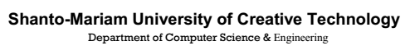





**School Management System**



**Cantonment Public School**

**January - 2018**

**School Management System**



**Cantonment Public School**

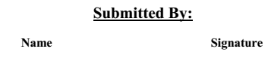

**Ruma Rani Das ………………………………….**

**ID: 131071005**

**UmmaHabiba Sharna ………………………………….**

**ID: 131071011**

**Asma Sadia ………………………………….**

**ID: 132061003**



**Mr. A. H. Shohel Ahmed**

**Assistant Professor ………………………………….**

**Department of CSE & CSIT**



This is to certify that the Project entitled **“Developing WEB Based School Management System for Cantonment Public School”** has been carried out by **Ruma Rani Das,** **UmmaHabiba Sharna, and Asma Sadia** from the Department of Computer Science and Engineering (CSE) & Computer Science and Information Technology (CSIT) at Shanto-Mariam University of Creative Technology, Dhaka, Bangladesh. This project has been accepted as satisfactory for the partial fulfillment of the requirements of the degree of Bachelor of Computer Science and Engineering (CSE) & Computer Science and Information Technology (CSIT) approved as to its style and contents.

**…………………………………. ………………………………….**

**(Mr. A. H. Shohel Ahmed)**

**Assistant Professor**

**Department of CSE & CSIT**

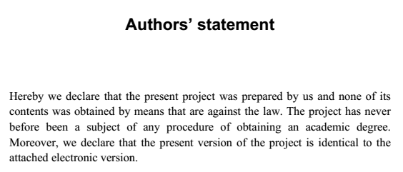

**Date:**  **Authors’ Signature:** **………………………………….**

(**Ruma Rani Das)**

**………………………………….**

(**UmmaHabiba Sharna)**

**………………………………….**

(**Asma Sadia)**

